THREE FOLD GOALS OF A FAMILY

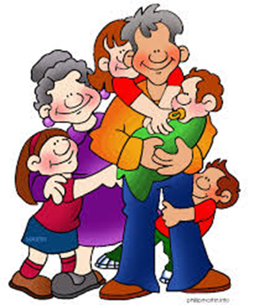
- The family provides us in body and mind with the necessities for an ordered daily life or family life.
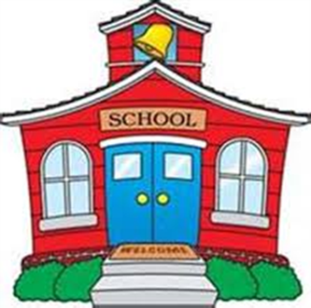

- The family provides for the procreation
and education of children.
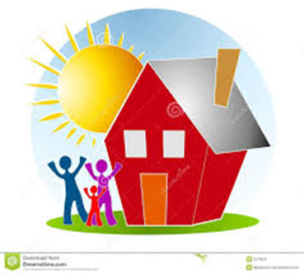

- The family contributes to the development of the society.

TYPES AND FORMS OF FAMILIES

1. According to Internal Organization

- Conjugal Family
- This is composed of a husband and wife unit.

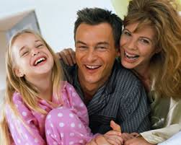
- Nuclear Family
- A family consisting only of the father, mother, and children.
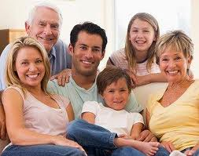
Extended Family
- A family consisting of parents and their children and their relatives.

2. According to Organized Descent Grouping
- Patrilineal Family
- A family that traces its ancestry from the paternal or father’s side.
- Matrilineal Family
- A family that traces its ancestry from the maternal or mother’s side.
- Bilineal Family
- A family that traces its ancestry from both paternal and maternal sides.

3. According to Location of Residences
- Patrilocal Family
- Family in which the newlyweds live parents of husband
- Matrilocal Family
- Family in which the newlyweds live with parents of the wife.

- Bilocal Family
- The married couple who come from the same community establish their residence in the same community.
- Neolocal Family
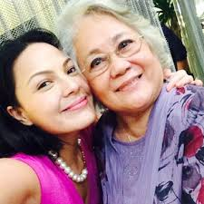
- Family in which the newlyweds have their own home at once.

4. According to the Degree of Authority
- Patriarchal Family
- Family in which the father is the head, dominant, and makes major decision.
- Matriarchal Family
- Family in which the mother is the head, dominant and makes major decision.
- Equalitarian Family
- Family in which husband and wife have equal authority and jointly make major decision.

5. Today’s Family
- Blended Family
- A family that consists of members from two (or more) previous families.

- Single-Parent Family
- This can be either a father or a mother who is singly responsible for raising the child.

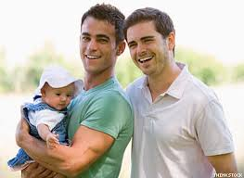
- Gay and Lesbian Parent Family
- A family in which the parents are lesbians or gays.

Grandparent Reared Family
- Grandparents today are raising their grandchildren.
- Adoptive Family
- A family where one or more of the children has been adopted.

CHARACTERISTICS OF THE FAMILY

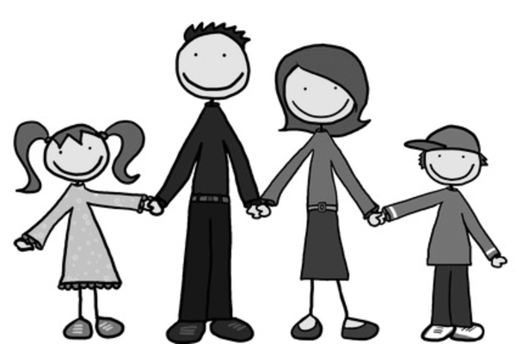
- Group of people united by ties of marriage, blood or adoption.
TYPES AND FORMS OF FAMILIES
- Usually live together under one roof and constitute a single housekeeping unit.
- Associate with one another in their respective role relationships.
- They tend to create a common subculture.
- Constitute the foundation of a larger social structure.

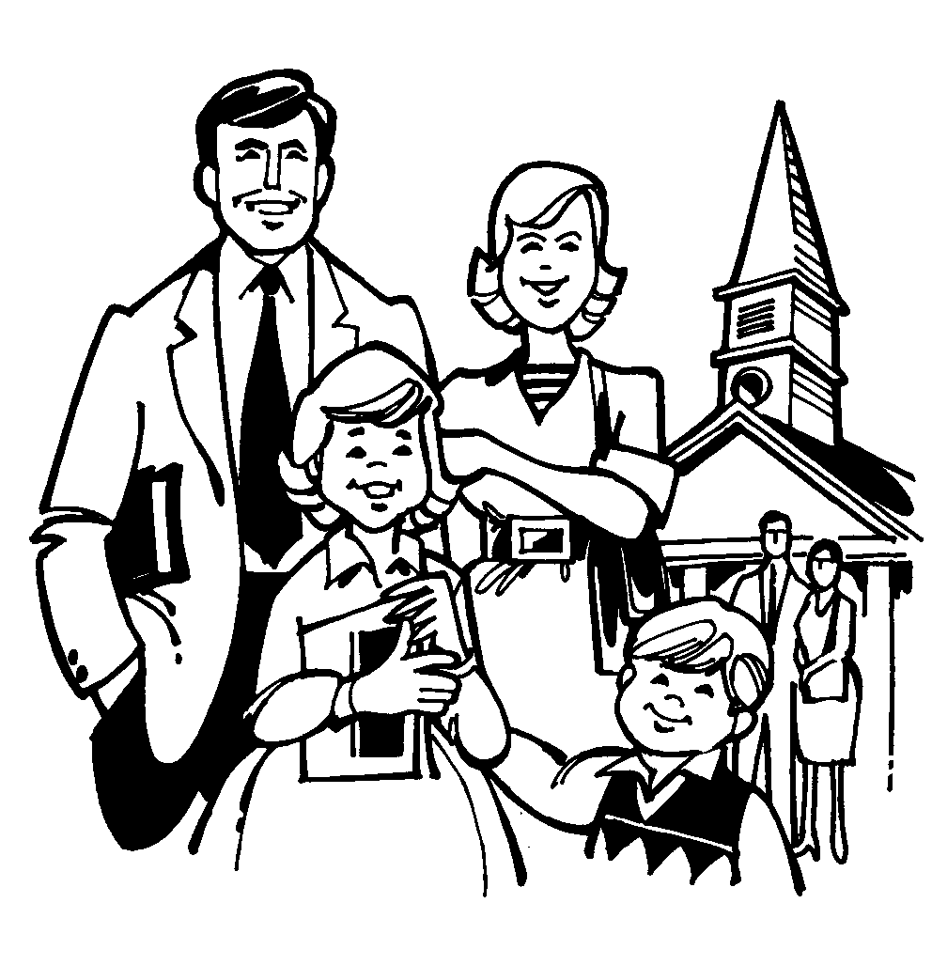
DEFINITION OF ‘FAMILY’

A group of people who are related through marriage, blood, or adoption; interact with one another in their designated roles of husband, wife, father, mother, son, daughter, brother, sister, uncle, aunt, cousin, or grandparent; and create and maintain a common subculture. (Lantz and Snyder, 1961)
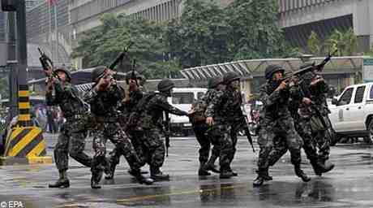
FUNCTIONS OF THE FAMILY

- Regulates sexual behavior and is the unit of reproduction
- Performs the function of biological maintenance
- Chief agency for socializing the child
- Gives its members status
- Important mechanism for social control
- Educational, economic, recreational, religious and
political functions
FACTORS AFFECTING
FILIPINO FAMILIES

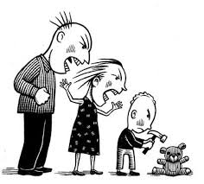

1. Violence in the family takes many forms, some of which are so subtle that we are not even aware that they are happening.
EFFECTS:
1. From a subtle putdown to favoritism
2. From minor insult to verbal abuse
3. Fighting of the parents witnessed by the children escalating to physical and sexual abuse.
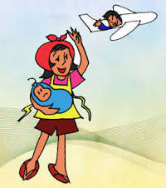
2. Global and Urban Migration – when member/s of the family move to a different place to work

EFFECTS:
1. Many families become single-parent families.
2. The children become ‘seasonal orphans.’

3. Political Instability – the family became insecure because they don’t know what will happen next in our government so they can’t fully rely on it.

EFFECTS:
1. The unpredictability and uncertainty of the family lead to anxiety.

4. Changing Role of Women – women became the workers instead of taking care of the household.

EFFECTS:
1. Increasing number of teenage pregnancy and youth-parents because of lack of provision of a mother.
2. The father becomes insecure of himself.

5. Media and Technology – families that used to be very close to each other are threatened, it also exposes members to violence without educational component.
EFFECTS:
1. Too much exposure to violent crimes and sex brings damage to the upbringing of the children.
2. The interpersonal relationship of the family seems to be neglected.

FILIPINO VALUES SYSTEM

Cultural values are shared assumption of what is right , good or important in a certain society.
Filipino Values System is defined by the way of people live their life as an influence of one’s culture. It is the set of values or the value system that a majority of the Filipinos have historically held important in their lives consisting their own unique assemblage of consistent ideologies , moral code , ethical principles , etiquette and cultural and personal values that are promoted by their society.

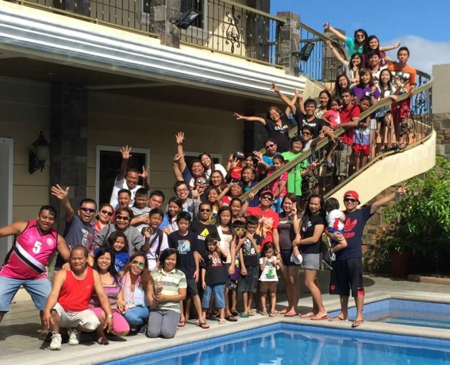
- Pagkakabuklod-buklod
The Filipinos recognize their family as an important social structure that one must take care of. They give importance to the safety and unity of one’s family. It is also common to find the whole clan living in the same area and have extended family structure.

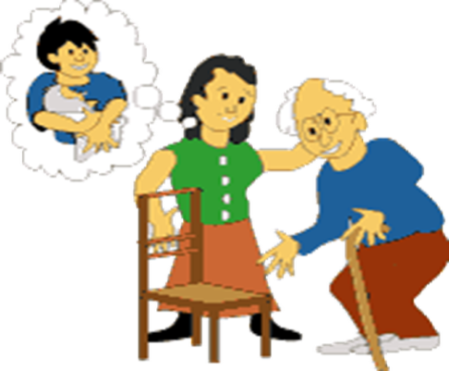
- Utang na loob
It is a technique of reciprocity of debt of gratitude to others within the family circle or primary group , sometimes unlimited in nature , emotional rather than financial or rational.

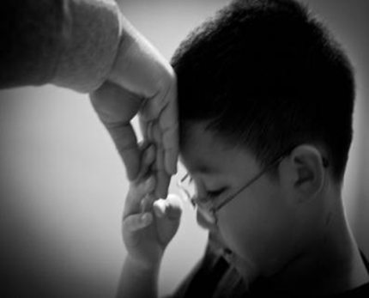
- Galang
Filipinos are taught to become respectful individuals. This is mainly due to the influence of Christianity that tells us to honor both our parents and our elders. The use of ‘’po’’ and ‘’’opo’’ in conversation and “mano”.

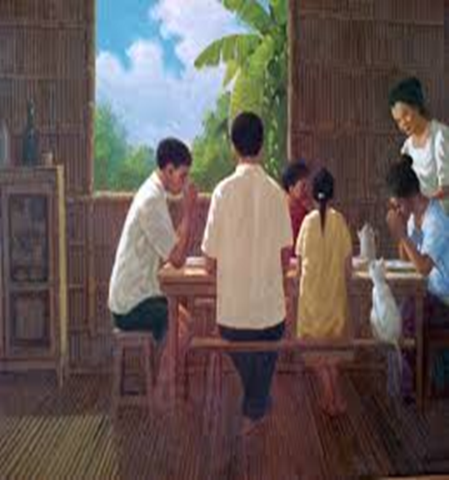
- Pagkarelihiyoso
Filipinos are religious. They believe so much in supernatural powers and taught them to trust prayers rather than hard work in the realization of their dreams. Succes is considered a blessing from above.

- Damayan/Balikatan
Denotes a good relationship among the people in the family or within the group or community and connotes
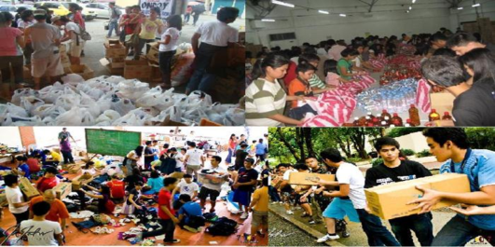
helping one another in time of need. Filipinos engage themselves in mutual cooperation.

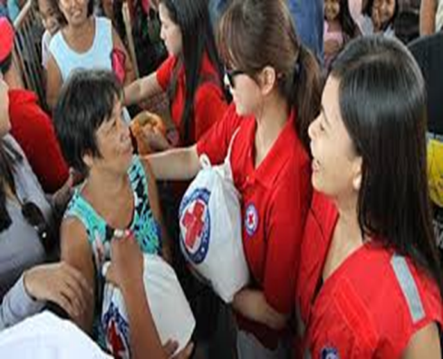
- Malasakit
In Filipino Family each of the member have the adherence or the willingness to help the other member who is in need more than they do , emotional or financial needs. They have this care to their family member and this is the way they show their love to each other.

A Prayer for Family
Heavenly Father, Please shine your light upon my family. Give us strength to overcome all of the difficulties that we are dealing with now and protect us against any and all problems we may encounter in the future. O Lord, please bring us together as we are meant to be. May the love that binds us only grow stronger as we fulfill the destiny you have laid out for us.
Grant my family forgiveness for any sins we have committed. May we also forgive one another Lord, as it is sometimes difficult to do.
Bless us Lord, in your name I pray, Amen
GROUP II

CAPULE , Norilyn Ann
GABUAT , Ma. Rhodora
ESTRELLA , Esther
LAZARO , Alyssa Mikhaella
MOLANO , Angelica
PRIOLO , Romeo

